Report
Of
Java Full Stack Development With Project
(AICTE – EduSkills Virtual Internship)
Submitted
To
School of Computer Science and Engineering
IILM University, Greater Noida, U.P.
In partial fulfilment of the requirement of degree of
B.Tech CSE

By
Roll Number of Student: 2410030999
Name of Student: RAVI SHANKAR KUMAR
Batch: 2024-2028
2024-2028

CANDIDATE’S DECLARATION
I, Ravi Shankar Kumar, do hereby declare that the internship report titled “Java Full Stack Development With Project” has been completed by me to fulfil the requirement for the award of the degree of Bachelor of Technology in CSE. All the references have been quoted and I have not taken as such any material from any other source. I affirm to you that this report is my own and has not been submitted to any other institute for any degree/diploma requirement and further I shall be solely responsible for any kind of copyright violation in this regard.
Signature
Student Name: Ravi Shankar Kumar
Roll No.: 2410030999

ACKNOWLEDGEMENT
I am using this opportunity to express my gratitude to everyone who supported me throughout the Internship Program. I am thankful for their aspiring guidance, invaluably constructive criticism and friendly advice during this work. I am sincerely grateful to them for sharing their truthful and illuminating views on a number of issues related to this work.
I express my gratitude to my parents for their blessings.
Signature
Student Name: Ravi Shankar Kumar
Roll No.: 2410030999

INTERNSHIP COMPLETION CERTIFICATE
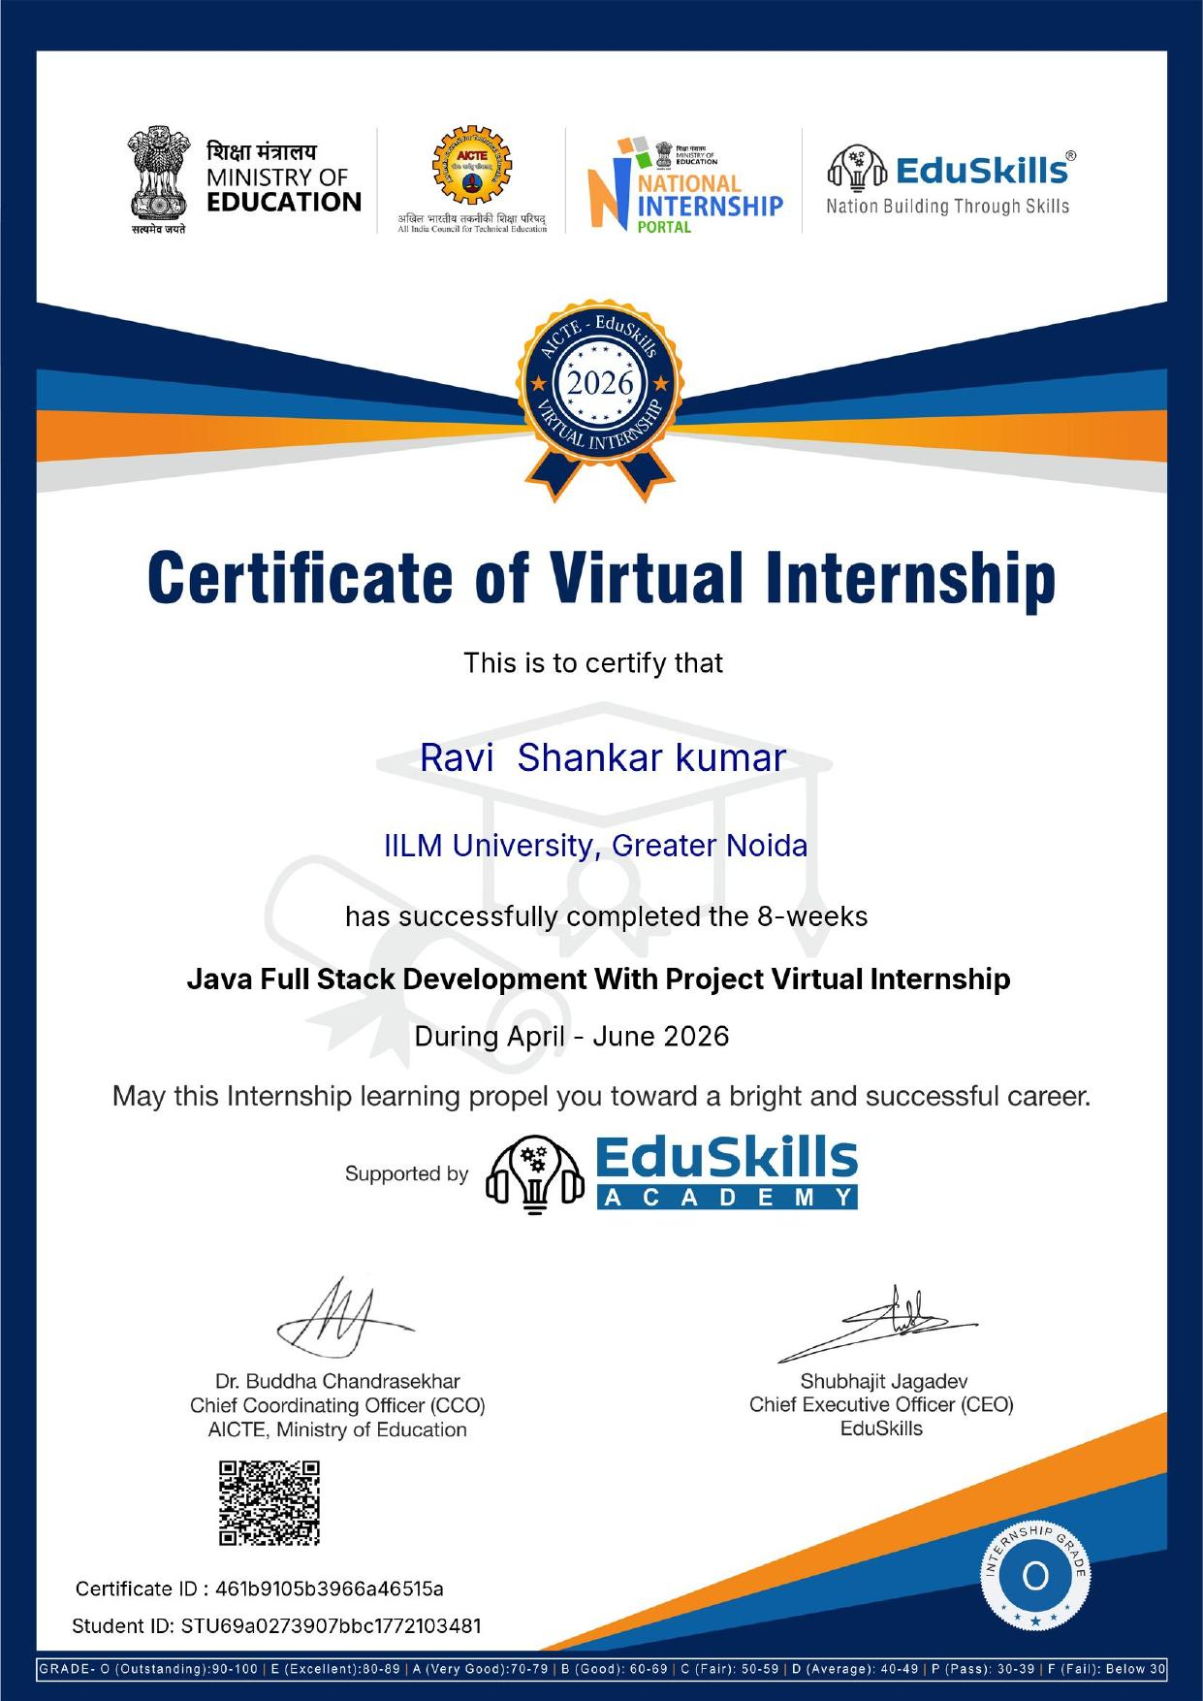

TABLE OF CONTENTS
Chapter No. | Chapter Name | Page Nos.
 | Cover Page
1. | Candidate’s Declaration
2. | Acknowledgment
3. | Internship Completion Certificate
4. | Project Description  4.1 Introduction  4.2 Organization Profile  4.3 Problem Statement  4.4 Project Objectives  4.5 Scope of the Project  4.6 Technologies and Tools Used  4.7 System Architecture  4.8 Methodology  4.9 Expected Outcomes  4.10 Certificates of Completion and Communication Proof
5. | Bibliography/References

CHAPTER 4: PROJECT DESCRIPTION
4.1 Introduction
This report presents the work undertaken during the 8-week “Java Full Stack Development With Project” Virtual Internship, conducted under the AICTE – EduSkills National Internship Portal initiative (April–June 2026). The internship provided practical, industry-oriented exposure to full stack web development using Java technologies, combining structured self-paced learning modules with a hands-on capstone project. This chapter documents the organisation behind the program, the problem addressed by the capstone project, the objectives and scope of the work, the technologies used, the system architecture, the methodology followed, and the expected outcomes.
4.2 Organization Profile
The internship was conducted under the AICTE – EduSkills National Internship Portal program, an initiative supported by the Ministry of Education, the All India Council for Technical Education (AICTE), and EduSkills Academy. EduSkills Academy partners with academia and industry to deliver skill-based virtual internship programs that help engineering students gain practical, job-ready competencies aligned with current industry requirements. The program was undertaken while enrolled at IILM University, Greater Noida, U.P., which facilitated student participation in the initiative.
4.3 Problem Statement
Note: the exact problem statement/domain of the capstone project was not confirmed at the time of drafting. The description below follows the standard problem framing used in this EduSkills Java Full Stack curriculum and should be edited to match the specific project once finalised.
Many small-scale record-keeping and service processes are still managed manually or through disconnected spreadsheets, leading to data duplication, delays, and limited accessibility. There is a need for a centralised, web-based application that allows users to create, view, update, and delete records reliably through a simple interface, while ensuring the underlying data is stored securely and consistently in a relational database.
4.4 Project Objectives
- To design and develop a full stack web application using Java, Spring Boot, and MySQL.
- To build a responsive front-end interface using HTML, CSS, and JavaScript.
- To implement RESTful APIs for create, read, update, and delete (CRUD) operations.
- To design a normalised relational database schema for reliable data storage.
- To apply a layered (MVC-style) architecture for maintainability and scalability.
- To test, debug, and deploy the completed application.
4.5 Scope of the Project
The scope of the project covers the design and development of a database-driven full stack web application, including front-end pages for user interaction, back-end REST APIs for business logic, and a MySQL database for persistent storage. The project focuses on core CRUD functionality, input validation, and a layered architecture; it does not extend to large-scale production deployment, load testing, or third-party payment/integration services, which are outside the scope of an 8-week learning-oriented internship.
4.6 Technologies and Tools Used
- Programming Language: Java (Core Java, OOP concepts)
- Back-end Framework: Spring / Spring Boot (REST APIs, Spring Data JPA)
- Front-end: HTML5, CSS3, JavaScript
- Database: MySQL
- Tools: Eclipse / IntelliJ IDEA, Postman, Git & GitHub, Maven
4.7 System Architecture
The application follows a layered (MVC-style) architecture consisting of the following layers:
- Presentation Layer: HTML, CSS, and JavaScript pages that interact with the user.
- Controller Layer: Spring Boot REST controllers that receive and route HTTP requests.
- Service Layer: Contains the core business logic of the application.
- Repository Layer: Spring Data JPA repositories that interact with the database.
- Database Layer: MySQL database that stores application data persistently.
Data flows from the front end to the Controller layer, which delegates processing to the Service layer; the Service layer uses the Repository layer to read from or write to the MySQL database, and the response is returned back through the same layers to the user interface.
4.8 Methodology
Week | Focus Area | Activities
Week 1 | Orientation & Java Fundamentals | Program orientation; Core Java refresher — OOP concepts, collections, exception handling.
Week 2 | Advanced Java & Databases | Multithreading basics, JDBC, and relational database design with MySQL.
Week 3 | Web Fundamentals | HTML5, CSS3, and JavaScript for building responsive front-end pages.
Week 4 | Server-Side Java (Servlets/JSP) | Java Servlets, JSP, and the MVC pattern for web applications.
Week 5 | Spring & Spring Boot | Spring core concepts, dependency injection, and building REST APIs with Spring Boot.
Week 6 | Spring Data & Security | Spring Data JPA for persistence, and securing endpoints with Spring Security basics.
Week 7 | Capstone Project Development | Designing and building the full-stack capstone project end to end.
Week 8 | Testing, Deployment & Presentation | Unit testing, debugging, deployment, and final project presentation.

4.9 Expected Outcomes
- A working full stack web application demonstrating CRUD functionality end to end.
- Strengthened understanding of Core Java, Spring Boot, and REST API development.
- Practical experience in relational database design and querying using MySQL.
- Improved front-end development skills using HTML, CSS, and JavaScript.
- Hands-on exposure to industry tools such as Git/GitHub, Postman, and Maven.
- Enhanced debugging, documentation, and project presentation skills.
4.10 Certificates of Completion and Communication Proof
The Certificate of Virtual Internship issued by AICTE, Ministry of Education, National Internship Portal, and EduSkills Academy — confirming successful completion of the 8-week “Java Full Stack Development With Project” Virtual Internship with Grade O (Outstanding), Certificate ID 461b9105b3966a46515a — is attached in Chapter 3 (Internship Completion Certificate) of this report.

CHAPTER 5: BIBLIOGRAPHY/REFERENCES
1. Oracle Corporation, “Java Documentation,” Available: https://docs.oracle.com/en/java/
2. Spring, “Spring Boot Reference Documentation,” Available: https://spring.io/projects/spring-boot
3. Oracle Corporation, “MySQL 8.0 Reference Manual,” Available: https://dev.mysql.com/doc/
4. Mozilla Developer Network, “HTML, CSS and JavaScript Documentation,” Available: https://developer.mozilla.org/
5. AICTE – EduSkills, “National Internship Portal,” Available: https://internship.aicte-india.org/
6. EduSkills Academy, “Java Full Stack Development With Project – Virtual Internship Program,” 2026.

